Floodplain Ordinance 2023
Pend Oreille County

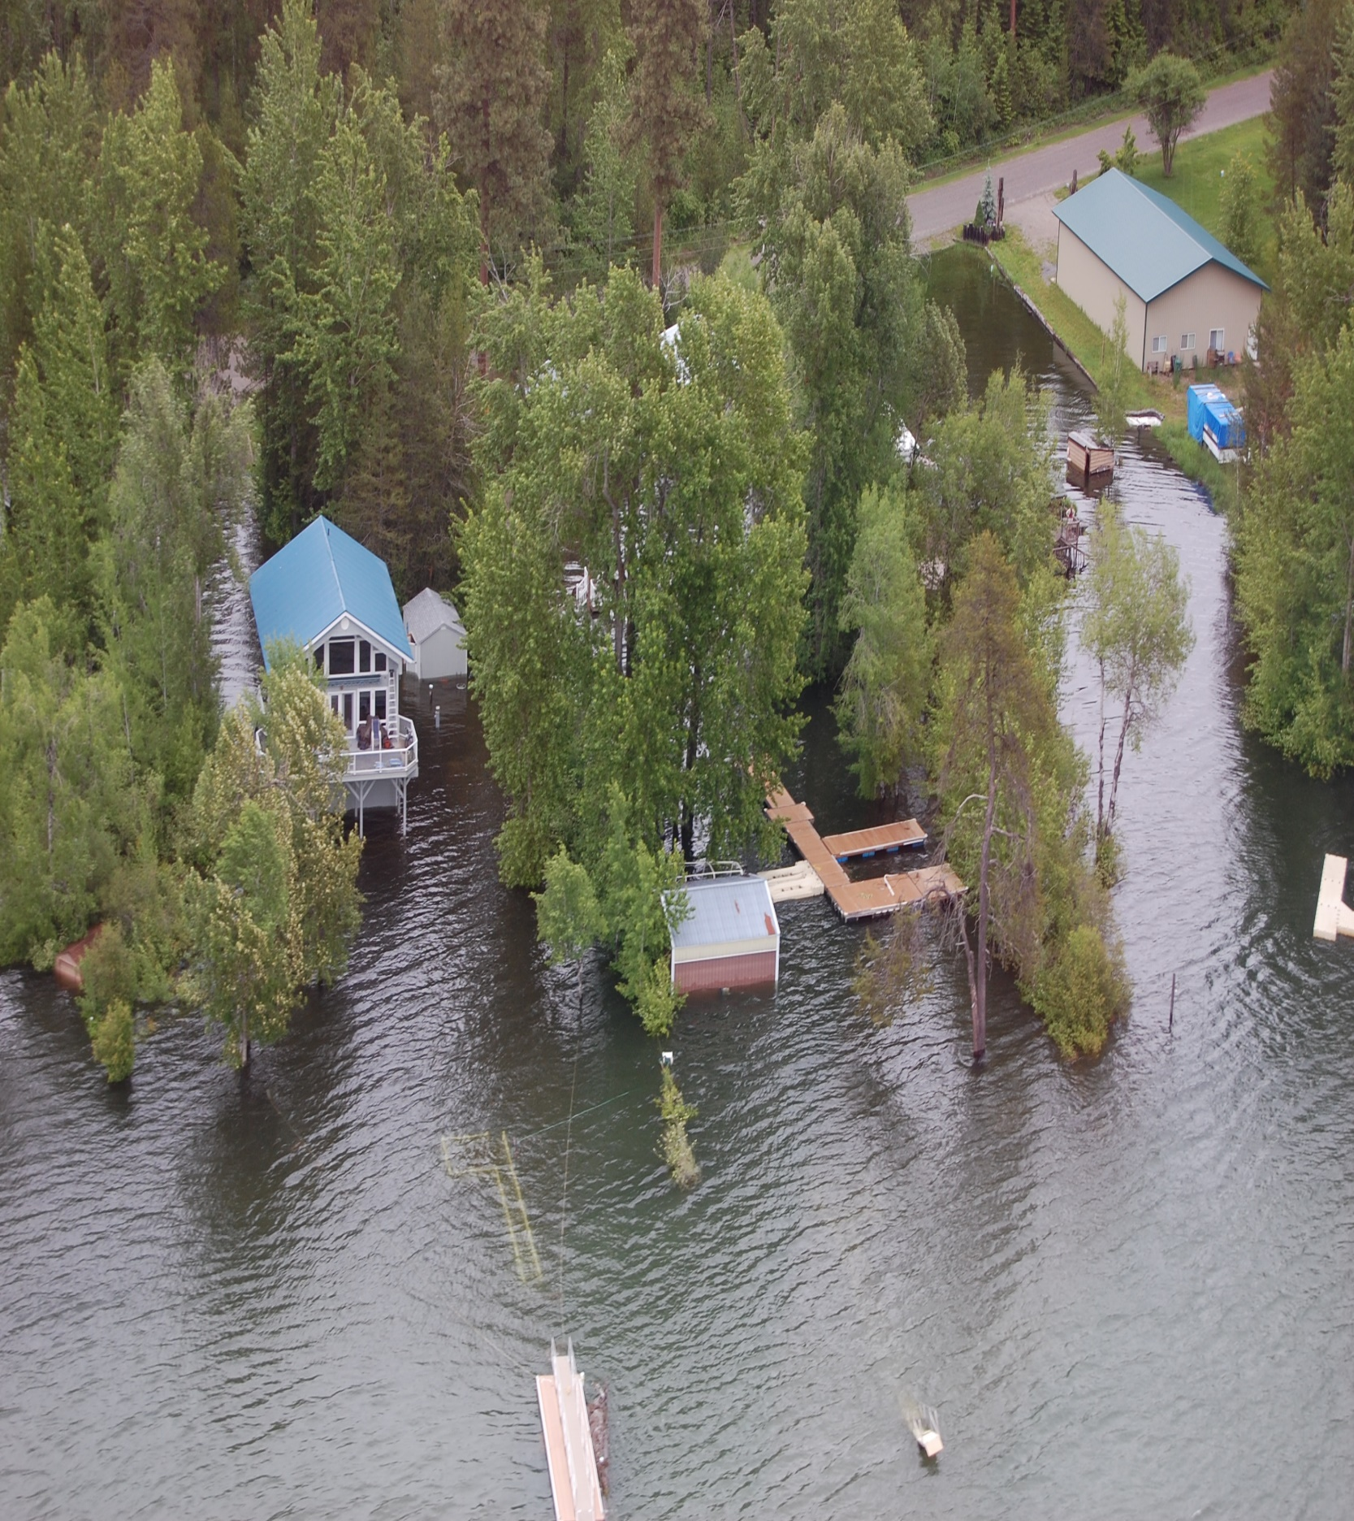

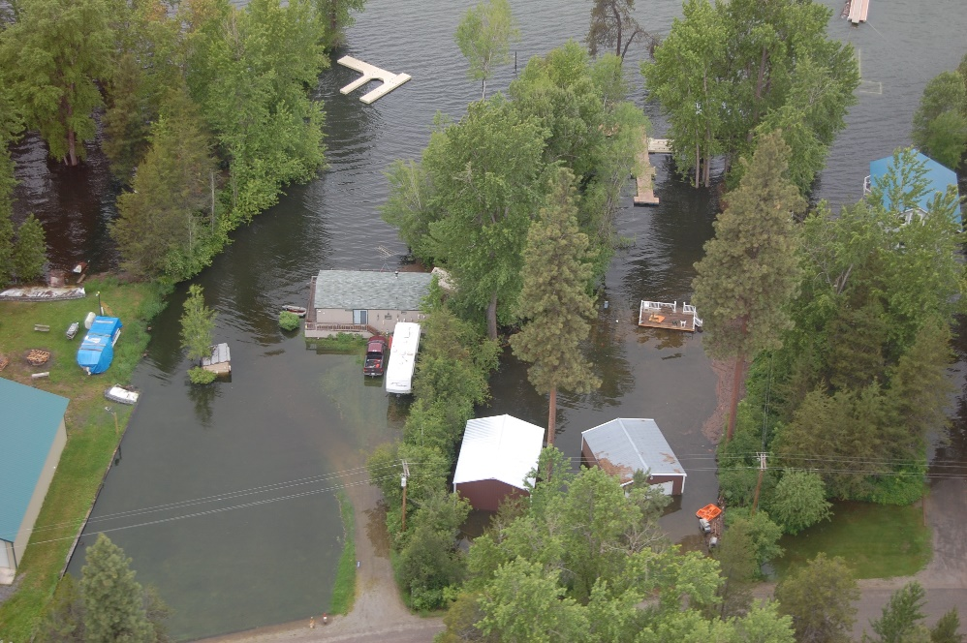

Table of Contents
A. Applicability 1
B. Purpose. 1
C. Classification 2
D. Review Process. 3
E. Duties and Responsibilities of the Floodplain Administrator. 3
F. General Regulations. 7
G. Specific Standards 9
H. AE and A1-30 Zones with Base Flood Elevations but No Floodway 13
I. Floodways. 14
J. General Requirements for Other Developmen 16
K. Livestock Sanctuaries. 17
L. Standards for shallow flooding areas (AO zones). 17

Floodplain Ordinance
xx.36.070 Frequently Flooded Areas.

- Applicability. This Section shall apply to all areas of Special Flood Hazard within the jurisdiction of Pend Oreille County.

- Purpose.
1. The purpose of this section is to:
      - Protect human life and health;
      - Minimize expenditure of public money and costly flood control and flood relief projects;
      - Minimize prolonged business interruptions;
      - Minimize damage to public facilities and utilities such as water mains, electric, telephone and sewer lines, streets, and bridges located in areas of special flood hazard;
      - Help maintain a stable tax base by providing for the sound use and development of areas of special flood hazard so as to minimize future flood damages;
      - Ensure that potential buyers are notified that property is in an area of special flood hazard; and,
      - Ensure that those who occupy the areas of special flood hazard assume responsibility for their actions.
      - Administer the Washington State Floodplain Management Act (Chapter 86.16
RCW) and maintain Pend Oreille County’s eligibility to participate in the National Flood Insurance Program.

2. This section includes methods and provisions for:
      - Restricting or prohibiting uses which are dangerous to health, safety, and property due to water or erosion hazards, or which result in damaging increases in erosion or in flood heights or velocities;
      - Requiring that uses vulnerable to floods, including facilities which serve such uses, be protected against flood damage at the time of initial construction;

3. Sewer and Water Services. The Project Sponsor shall provide sufficient documentation to verify, subject to County review and approval, that adequate provisions can be made to provide water and sewer service to the site, including but not limited to sufficient water rights, without adversely affecting existing levels of service.
      - Controlling filling, grading, dredging, and other development which may increase flood damage; and
      - Preventing or regulating the construction of flood barriers that will unnaturally divert floodwaters or may increase flood hazards in other areas.

4. The degree of flood protection required by this Section is considered reasonable for regulatory purposes and is based on scientific and engineering considerations. Larger floods can and will occur on rare occasions. Flood heights may be increased by manmade or natural causes. This does not imply that land outside the areas of special flood hazards or uses permitted within such areas will be free from flooding or flood damages.

- Classification. The areas of special flood hazard identified by the Federal Emergency Management Agency in a scientific and engineering report entitled “The Flood Insurance Study - Pend Oreille County, Washington and Incorporated Areas”, dated March 4, 2002, and any revisions thereto, with an accompanying Flood Insurance Rate Maps (FIRMs), and any revisions thereto, are hereby adopted by reference. The Flood Insurance Study and the FIRMs are on file at the County Courthouse.

The best available information for flood hazard area identification as outlined in Section xx.36.070.E.3 shall be the basis for regulation until a new FIRM is issued that incorporates data utilized under Section xx.36.070.E.3.
    - Area of “special flood hazard” means the land in the flood plain within a community subject to a one- percent or greater chance of flooding in any given year. Designation on maps always includes the letter A. Also referred to as “100-year floodplain” and “Special Flood Hazard Area”.

    - “Base flood” means the flood having a one percent chance of being equaled or exceeded in any given year. Also referred to as the “100-year flood.”

- Review Process.
    - A floodplain development permit shall be obtained before any construction or development activity is initiated within any special flood hazard area. The permit shall be for all structures including manufactured homes, as set forth in the “Definitions,” and for all development including fill and other activities, also as set forth in the “Definitions.”

    - Application for Development Permit.
Application for a development permit shall be made on forms furnished by the Floodplain Administrator and may include, but not be limited to, plans in duplicate drawn to scale showing the nature, location, dimensions, and elevations of the area in question; existing or proposed structures, fill, storage of materials, drainage facilities, and the location of the foregoing. Specifically, the following information is required:
- Elevation in relation to mean sea level, of the lowest floor (including basement) of all structures recorded on a current elevation certificate with Section B completed by the Floodplain Administrator.
- Elevation in relation to mean sea level to which any structure has been floodproofed;
- Where a structure is to be floodproofed, certification by a registered professional engineer or architect that the floodproofing methods for any nonresidential structure meet floodproofing criteria in Section xx,36.070.G.3.
- Description of the extent to which a watercourse will be altered or relocated as a result of proposed development;
- Where development is proposed in a floodway, an engineering analysis indication no rise of the Base Flood Elevation, and
- Any other such information that may be reasonably required by the Floodplain Administrator in order to review the application.

- Duties and Responsibilities of the Floodplain Administrator.
- The Community Development Director is hereby appointed to administer, implement, and enforce this ordinance by granting or denying development permits in accordance with its provisions. The Floodplain Administrator may delegate authority to implement these provisions.
- The Community Development Director shall:
      - Notify adjacent communities and the Department of Ecology prior to any alteration or relocation of a watercourse and submit evidence of such notification to the Federal Emergency Management Agency.
      - Require that maintenance be provided within the altered or relocated portion of said watercourse so that the flood carrying capacity is not diminished.
      - Administer and implement these regulations by granting or denying development applications in accordance with the provisions of this Chapter. This shall include but is not limited to the:
        - Review all development permits to determine that the permit requirements of this ordinance have been satisfied.
        - Review all development permits to determine that all necessary permits have been obtained from those Federal, State, or local governmental agencies from which prior approval is required.
        - The site is reasonably safe from flooding;
        - The proposed development is not located in the floodway. If located in the floodway, assure the encroachment provisions of Section xx,36.070.I are met;
      - Notify FEMA when annexations occur in the Special Flood Hazard Area.

- Use of other base flood data. When base flood elevation data has not been established for areas of special flood hazard, the Community Development Director shall obtain, review, and reasonably utilize any base flood elevation and floodway data available from a Federal, State or other source in accordance with accepted engineering practices.

- Information to be obtained and maintained.
      - Where base flood elevation data is provided through the Flood Insurance Study, FIRM, or required as in section xx.36.070.E.3, obtain and record the actual (as built) elevation (in relation to mean sea level) of the lowest floor (including basement) of all new or substantially improved structures, and whether or not the structure contains a basement. (CFR 60.3(b)(5)(i)) Recorded on a current elevation certificate (FF 81-31) with Section B completed by the local official.
      - For all new or substantially improved floodproofed nonresidential structures where base flood elevation data is provided through the FIS, FIRM:
        - Obtain and record the elevation (in relation to mean sea level to which the structure was floodproofed).
        - Maintain the floodproofing certifications required in Section xx.36.070.G.3 (44 CFR 60.3 (b) (5) (iii)).
c. Certification required by Section xx,36.070.I (floodway encroachments). (44 CFR 60.3(d)(3))
d. Records of all variance actions, including justification for their issuance. (44 CFR 60.6(a)(6))
e. Improvement and damage calculations.
f. Maintain for public inspection all records pertaining to the provisions of this Chapter.

- Interpretation of FIRM Boundaries. Make interpretations where needed, as to exact location of the boundaries of the areas of special flood hazards (e.g. where there appears to be a conflict between a mapped boundary and actual field conditions). The person contesting the location of the boundary shall be given a reasonable opportunity to appeal the interpretation. Such appeals shall be granted consistent with the standards of Section 60.6 of the Rules and Regulations of the NFIP (44 CFR 59-76).

- Review of Building Permits. Where elevation data is not available either through the Flood Insurance Study, FIRM, or from another authoritative source, applications for building permits shall be reviewed to assure that proposed construction will be reasonably safe from flooding. The test of reasonableness is a local judgment and includes use of historical data, high water marks, photographs of past flooding, etc., where available. Failure to elevate at least two feet above the highest adjacent grade in these zones may result in higher insurance rates.

- Changes to Special Flood Hazard Area.
- If a project will alter the BFE or boundaries of the SFHA, then the project proponent shall provide the community with engineering documentation and analysis regarding the proposed change. If the change to the BFE or boundaries of the SFHA would normally require a Letter of Map Change, then the project proponent shall initiate, and receive approval of, a Conditional Letter of Map Revision (CLOMR) prior to approval of the development permit. The project shall be constructed in a manner consistent with the approved CLOMR.
- If a CLOMR application is made, then the project proponent shall also supply the full CLOMR documentation package to the Floodplain Administrator to be attached to the floodplain development permit, including all required property owner notifications.

- Variances.
- Variances may be granted when the following conditions exist:
      - Variances shall not be issued within any designated floodway if any increase in flood levels during the base flood discharge would result. Variance requests in the designated floodway shall be accompanied by a professional engineering analysis of the resultant base flood discharge. Variances shall not be granted from the provisions of Section XX.36.030.F.2.
      - Variances may be issued for nonresidential buildings in very limited circumstances to allow a lesser degree of floodproofing than watertight or dry floodproofing, where it can be determined that such action will have low damage potential and comply with all other variance criteria.
      - Any applicant to whom a variance is granted shall be given written notice that the structure will be permitted to be built with a lowest floor elevation below the base flood elevation and that the cost of flood insurance will be commensurate with the increased risk resulting from the reduced lowest floor elevation.
      - Variances may be issued for the reconstruction, rehabilitation, or restoration of structures listed on the National Register of Historic Places or the State Inventory of Historic Places, without regard to the procedures set forth in this section.
      - Generally, the only condition under which a variance from the elevation standard may be issued is for new construction and substantial improvements to be erected on a lot one-half acre or less in size contiguous to and surrounded by lots with existing structures constructed below the base flood elevation. As the lot size increases, the technical justification required for issuing the variance increases.
- Variances to the provisions of this Section may be granted upon consideration of:
        - The danger that materials may be swept onto other lands to the injury of others;
        - The danger to life and property due to flooding or erosion damage;
        - The susceptibility of the proposed facility and its contents to flood damage and the effect of such damage on the individual owner;
        - The importance of the services provided by the proposed facility to the community;
        - The necessity to the facility of a waterfront location, where applicable;
        - The availability of alternative locations for the proposed use which are not subject to flooding or erosion damage
        - The compatibility of the proposed use with existing and anticipated development;
        - The relationship of the proposed use to the comprehensive plan and flood plain management program for the area;
        - The safety of access to the property in times of flood for ordinary and emergency vehicles;
        - The expected heights, velocity, duration, rate of rise, and sediment transport of the flood waters and the effects of wave action, if applicable, expected at the site; and,
        - The costs of providing governmental services during and after flood conditions, including maintenance and repair of public utilities and facilities such as sewer, gas, electrical, and water systems, and streets and bridges.

- General Regulations.
- Anchoring.
      - All new construction and substantial improvements shall be anchored to prevent flotation, collapse, or lateral movement of the structure.
      - All manufactured homes must likewise be anchored to prevent flotation, collapse, or lateral movement, and shall be installed using methods and practices that minimize flood damage. Anchoring methods may include, but are not limited to, use of over-the-top or frame ties to ground anchors (Reference FEMA’s “Manufactured Home Installation in Flood Hazard Areas” guidebook for additional techniques).

- AH Zone Drainage. Adequate drainage paths are required around structures on slopes to guide floodwaters around and away from proposed structures.

    - Construction Materials and methods.
      - All new construction and substantial improvements shall be constructed with materials and utility equipment resistant to flood damage.
      - All new construction and substantial improvements shall be constructed using methods and practices that minimize flood damage.
      - Electrical, heating, ventilation, plumbing, and air-conditioning equipment and other service facilities shall be designed and/or otherwise elevated or located so as to prevent water from entering or accumulating within the components during conditions of flooding.

    - Utilities.
      - All new and replacement water supply systems shall be designed to minimize or eliminate infiltration of flood waters into the system;
      - New and replacement sanitary sewage systems shall be designed to minimize or eliminate infiltration of flood waters into the systems and discharge from the systems into flood waters;
      - Onsite waste disposal systems shall be located to avoid impairment to them or contamination from them during flooding;
      - New water wells shall be located on high ground that is not in the floodway (WAC 173-160-171);
      - Elevate or adequately anchor propane tanks if located below the regulatory flood elevation; and
      - Elevate or floodproof utilities below the regulatory flood elevation.

    - Storage of Materials and Equipment
a. The storage or processing of materials that could be injurious to human, animal, or plant life if released due to damage from flooding is prohibited in special flood hazard areas (recommended).
b. Storage of other material or equipment may be allowed if not subject to damage by floods and if firmly anchored to prevent flotation, or if readily removable from the area within the time available after flood warning.

6. Subdivision proposals.
  - All subdivision proposals shall be consistent with the need to minimize flood damage.
  - All subdivision proposals shall have public utilities and facilities such as sewer, gas, electrical, and water systems located and constructed to minimize flood damage.
  - All subdivision proposals shall have adequate drainage provided to reduce exposure to flood damage.
  - Where base flood elevation data has not been provided or is not available from another authoritative source, it shall be generated for subdivision proposals and other proposed developments which contain at least fifty lots or five acres (whichever is less).
  - All subdivisions and short subdivisions shall establish an elevation monument on or adjacent to the subject property for future elevation certification purposes.
  - All subdivisions and short subdivisions shall show on the face of the final plat or short plat, the boundary of the 100-year floodplain and floodway.
  - All subdivision proposals involving lands within the 100- year flood plain shall provide elevations at each lot corner.

- Specific Standards. In all areas of special flood hazards where base flood elevation data has been provided as set forth in Section C, Classification, or Section E(3), uof other base flood data, the following provisions are required:
    - Residential Construction.
  - In AE and A1-30 zones or other A zoned areas where the BFE has been determined or can be reasonably obtained, new construction and substantial improvement of any residential structure shall have the lowest floor, including basement, elevated one foot or more above the base flood elevation (BFE). Mechanical equipment and utilities shall be waterproof or elevated at least one foot above the BFE.
  - New construction and substantial improvement of any residential structure in an AO zone shall meet the requirements in xx.36.070.L.
  - New construction and substantial improvement of any residential structure in an Unnumbered A zone for which a BFE is not available and cannot be reasonably obtained shall be reasonably safe from flooding, but in all cases the lowest floor shall be at least two feet above the Highest Adjacent Grade.
  - Fully enclosed areas below the lowest floor that are subject to flooding are prohibited or shall be designed to automatically equalize hydrostatic and hydrodynamic flood forces on exterior walls by allowing for the entry and exit of floodwaters. Designs for meeting this requirement must either be certified by a registered professional engineer or architect or must meet or exceed the following minimum criteria:
        - A minimum of two openings having a total net area of not less than one square inch for every square foot of enclosed area subject to flooding shall be provided.
        - The bottom of all openings shall be no higher than one-foot above grade.
        - Openings may be equipped with screens, louvers, or other coverings or devices provided that they permit the automatic entry and exit of floodwaters.
        - A garage attached to a residential structure, constructed with the garage floor slab below the BFE, must be designed to allow for the automatic entry and exit of flood waters.
        - Alternatively, a registered engineer or architect may design and certify engineered openings.

- Detached accessory buildings (garages). The following special provisions apply to detached accessory structures used as garages to single-family residences. When an accessory structure is small and represents a minimal investment, the elevation or dry floodproofing standards need not be met. However, all other requirements applicable to structures will be applicable. A minimum investment shall be determined by the applicable guiding authority or by appeal under the variance procedure and shall be determined, if necessary, on a case-by-case basis. However, as a general application, expenditure for the accessory structure of not more than ten percent of the value of the main structure shall be considered a minimal investment. The structure shall be less than or equal to the size of a one-story, two-car garage.
  - Accessory structures shall not be used for human habitation and must be limited to parking and storage.
  - The accessory structure must be wet floodproofed to protect the structure from hydrostatic pressure. Accessory structures shall comply with the foundation opening requirements in Section XX.36.070.G.1.d and must allow for the automatic entry and exit of floodwaters without manual operation or the presence of a person (or persons).
  - Accessory structures shall be constructed and placed on the building site so as to offer the minimum resistance to the flow of floodwaters.
  - Accessory structures must be adequately anchored to prevent flotation, collapse, or lateral movement of the structure that may result in damage to other structures.
  - Accessory structures must comply with floodway encroachment provisions of this chapter and the National Flood Insurance Program.
  - Service facilities such as electrical and heating equipment shall be elevated one foot or more above the base flood elevation.
  - The portions of the accessory structure located below the BFE must be constructed with flood-resistant materials.
  - Applicants that elect not to elevate the lowest floor of accessory structures under the provisions of this section shall be notified that flood insurance premiums will be based on rates that are one foot below the base flood elevation.

- Nonresidential construction. New construction and substantial improvement of any commercial, industrial, or other nonresidential structure shall meet the requirements of subsection 1 or 2, below.
a. New construction and substantial improvement of any commercial, industrial or other nonresidential structure shall meet all of the following requirements:
- In AE and A1-30 zones or other A zoned areas where the BFE has been determined or can be reasonably obtained:
New construction and substantial improvement of any commercial, industrial, or other nonresidential structure shall have the lowest floor, including basement, elevated one foot or more above the BFE, or elevated as required by ASCE 24, whichever is greater. Mechanical equipment and utilities shall be waterproofed or elevated at least one foot above the BFE, or as required by ASCE 24, whichever is greater.

- If located in an AO zone, the structure shall meet the requirements in section xx.36.070.L.
- If located in an Unnumbered A zone for which a BFE is not available and cannot be reasonably obtained, the structure shall be reasonably safe from flooding, but in all cases the lowest floor shall be at least two feet above the Highest Adjacent Grade.
- Fully enclosed areas below the lowest floor that are subject to flooding are prohibited or shall be designed to automatically equalize hydrostatic flood forces on exterior walls by allowing for the entry and exit of floodwaters. Designs for meeting this requirement must either be certified by a registered professional engineer or architect or must meet or exceed the following minimum criteria:
    - Have a minimum of two openings with a total net area of not less than one square inch for every square foot of enclosed area subject to flooding.
    - The bottom of all openings shall be no higher than one foot above grade.
    - Openings may be equipped with screens, louvers, valves, or other coverings or devices provided that they permit the automatic entry and exit of floodwater.
    - A garage attached to a residential structure, constructed with the garage floor slab below the BFE, must be designed to allow for the automatic entry and exit of flood waters.

Alternatively, a registered engineer or architect may design and certify engineered openings.

b. If the requirements of subsection 1 are not met, then new construction and substantial improvement of any commercial, industrial or other nonresidential structure shall meet all of the following requirements:
- Be dry floodproofed so that below one foot or more above the base flood level the structure is watertight with walls substantially impermeable to the passage of water or dry floodproofed to the elevation required by ASCE 24, whichever is greater;
- Have structural components capable of resisting hydrostatic and hydrodynamic loads and effects of buoyancy;
- Be certified by a registered professional engineer or architect that the design and methods of construction are in accordance with accepted standards of practice for meeting provisions of this subsection based on their development and/or review of the structural design, specifications and plans. Such certifications shall be provided to the official as set forth in Section xx.36.070.E.4;
- Nonresidential structures that are elevated, not floodproofed, must meet the same standards for space below the lowest floor as described in xx.36.070.G.1.d;

- Critical facility. Construction of new, critical facilities shall be located outside the limits of the special flood hazard area. However, new construction and substantial improvement of both new and existing critical facilities shall be permissible within the 100-year floodplain, provided no feasible alternative site is available, and provided the facility’s nature is related to or necessitates a riverine location (such as municipal water and sewer pump stations and related treatment facilities).
    - Critical facilities shall have the lowest floor elevated three feet or more above the base flood elevation;
    - Floodproofing and sealing measures must be taken to ensure that toxic substances will not be displaced by or released into floodwaters; and,
    - Access routes to critical facilities shall be elevated to or above the base flood elevation to the extent possible.

- Manufactured homes. All manufactured homes shall be elevated on a permanent foundation such that the lowest floor of the manufactured home is elevated one foot or more above the base flood elevation and be securely anchored to an adequately designed and anchored foundation system to resist flotation, collapse and lateral movement.

- Recreational Vehicles. Recreational vehicles placed on sites are required to either be on a site for fewer than 180 days or be fully licensed and ready for highway use, on its wheels or jacking system, attached to the site only by quick disconnect type utilities and security devices, and have no permanently attached additions; or meet the requirements of this Section and the elevation and anchoring requirements for manufactured homes.

- Enclosed Area Below the Lowest Floor. If buildings or manufactured homes are constructed or substantially improved with fully enclosed areas below the lowest floor, the areas shall be used solely for parking of vehicles, building access, or storage.

- Crawlspaces and Basements.
- The interior grade of a crawlspace below the base flood elevation must not be more than two feet below the lowest adjacent exterior grade.
- The height of the below-grade crawlspace, measured from the interior grade of the crawlspace to the top of the crawlspace foundation wall, must not exceed four feet at any point.
- The height limitation is the maximum allowable unsupported wall height according to the engineering analyses and building code requirements for flood hazard areas (refer to FEMA Technical Bulletin 11-01, page 7, Guidance for Pre-Engineered Crawlspaces). This limitation is intended to prevent these crawlspaces from being converted into habitable spaces.
- There must be an adequate drainage system that removes floodwaters from the interior area of the crawlspace. The enclosed area should be drained within a reasonable time after a flood event. The type of drainage system will vary because of the site gradient and other drainage characteristics, such as soil types. Possible options include natural drainage through porous, well-drained soils and drainage systems such as perforated pipes, drainage tiles, or gravel or crushed stone drainage by gravity or mechanical means.
- The velocity of floodwaters at the site should not exceed five feet per second for any crawlspace. For velocities in excess of five feet per second, other foundation types should be used.

- AE and A1-30 Zones with Base Flood Elevations but No Floodways.
(44 CFR 60.3(c)(10)). In areas with BFEs (but a regulatory floodway has not been designated), no new construction, substantial improvements, or other development (including fill) shall be permitted within zones A1-30 and AE on the community’s FIRM, unless it is demonstrated that the cumulative effect of the proposed development, when combined with all other existing and anticipated development, will not increase the water surface elevation of the base flood more than one foot at any point within the community.

I. Floodways. Areas designated as floodways are located within areas of special flood hazard established in Section XX.36.070.C. Since the floodway is an extremely hazardous area due to the velocity of floodwaters which carry debris, potential projectiles, and erosion potential, the following provisions apply:
    - No rise standard. Prohibit encroachments, including fill, new construction, substantial improvements, and other development unless certification by a registered professional engineer is provided demonstrating through hydrologic and hydraulic analyses performed in accordance with standard engineering practice that the proposed encroachment would not result in any increase in flood levels during the occurrence of the base flood discharge.

    - Residential construction in floodways. Construction or reconstruction of residential structures is prohibited within designated floodways, except for:
      - Repairs, reconstruction, or improvements to a structure which do not increase the ground floor area; and
      - Repairs, reconstruction or improvements to a structure, the cost of which does not exceed 50 percent of the market value of the structure either, (i) before the repair, or reconstruction is started, or (ii) if the structure has been damaged, and is being restored, before the damage occurred. Any project for improvement of a structure to correct existing violations of state or local health, sanitary, or safety codes which have been identified by the local code enforcement official and which are the minimum necessary to assure safe living conditions or to structures identified as historic places shall not be included in the 50 percent.
      - Any development that results in additional walled and roofed space at a floor elevation at or below the ground floor shall constitute an increase in the ground floor area.
      - Replacement of Farmhouses in Floodway. Repairs, reconstruction, replacement, or improvements to existing farmhouse structures located in designated floodways and that are located on lands designated as agricultural lands of long-term commercial significance under RCW 36.70A.170 may be permitted subject to the following:
- The new farmhouse is a replacement for an existing farmhouse on the same farm site;
- There is no potential building site for a replacement farmhouse on the same farm outside the designated floodway;
- Repairs, reconstruction, or improvements to a farmhouse shall not increase the total square footage of encroachment of the existing farmhouse;
- A replacement farmhouse shall not exceed the total square footage of encroachment of the farmhouse it is replacing;
- A farmhouse being replaced shall be removed, in its entirety, including foundation, from the floodway within ninety days after occupancy of a new farmhouse;
- For substantial improvements and replacement farmhouses, the elevation of the lowest floor of the improvement and farmhouse respectively, including basement, is a minimum of one foot higher than the BFE;
- New and replacement water supply systems are designed to eliminate or minimize infiltration of flood waters into the system;
- New and replacement sanitary sewerage systems are designed and located to eliminate or minimize infiltration of flood water into the system and discharge from the system into the flood waters; and
- All other utilities and connections to public utilities are designed, constructed, and located to eliminate or minimize flood damage.
      - Substantially Damaged Residences in Floodway
- For all substantially damaged residential structures, other than farmhouses, located in a designated floodway, the Floodplain Administrator may make a written request that the Department of Ecology assess the risk of harm to life and property posed by the specific conditions of the floodway. Based on analysis of depth, velocity, flood-related erosion, channel migration, debris load potential, and flood warning capability, the Department of Ecology may exercise best professional judgment in recommending to the local permitting authority repair, replacement, or relocation of a substantially damaged structure consistent with WAC 173-158-076. The property owner shall be responsible for submitting to the local government and the Department of Ecology any information necessary to complete the assessment. Without a favorable recommendation from the department for the repair or replacement of a substantially damaged residential structure located in the regulatory floodway, no repair or replacement is allowed per WAC 173-158-070(1).
- Before the repair, replacement, or reconstruction is started, all requirements of the NFIP, the state requirements adopted pursuant to 86.16 RCW, and all applicable local regulations must be satisfied. In addition, the following conditions must be met:
- There is no potential safe building location for the replacement residential structure on the same property outside the regulatory floodway.
- A replacement residential structure is a residential structure built as a substitute for a legally existing residential structure of equivalent use and size
- Repairs, reconstruction, or replacement of a residential structure shall not increase the total square footage of floodway encroachment.
- The elevation of the lowest floor of the substantially damaged or replacement residential structure is a minimum of one foot higher than the BFE.
- New and replacement water supply systems are designed to eliminate or minimize infiltration of flood water into the system.
- New and replacement sanitary sewerage systems are designed and located to eliminate or minimize infiltration of flood water into the system and discharge from the system into the flood waters.
- All other utilities and connections to public utilities are designed, constructed, and located to eliminate or minimize flood damage.

- If subsection 1 is satisfied, all new construction and substantial improvements shall comply with all applicable flood hazard reduction provisions of Sections XX.36.070.F. and G.

- Filling in the floodway is prohibited except for residential maintenance. Residential maintenance is considered the importing of bark or topsoil for flowerbeds and gardens. The total amount of material shall not exceed 10 cubic yards per calendar year.

- Traditional agricultural practices are exempt.

J. General Requirements for Other Development.
All development, including manmade changes to improved or unimproved real estate for which specific provisions are not specified in this ordinance or the state building codes with adopted amendments and any {community name} amendments, shall:
- Be located and constructed to minimize flood damage;

- Meet the encroachment limitations of this ordinance if located in a regulatory floodway;

- Be anchored to prevent flotation, collapse, or lateral movement resulting from hydrostatic loads, including the effects of buoyancy, during conditions of the design flood;

- Be constructed of flood damage-resistant mater

- Meet the flood opening requirements of Section xx.36.070.G.1.d, and

6. Have mechanical, plumbing, and electrical systems above the design flood elevation or meet the requirements of ASCE 24, except that minimum electric service required to address life safety and electric code requirements is permitted below the design flood elevation provided it conforms to the provisions of the electrical part of building code for wet locations.

K. Livestock Sanctuaries.
Elevated areas for the for the purpose of creating a flood sanctuary for livestock are allowed on farm units where livestock is allowed. Livestock flood sanctuaries shall be sized appropriately for the expected number of livestock and be elevated sufficiently to protect livestock. Proposals for livestock flood sanctuaries shall meet all procedural and substantive requirements of this chapter.

Note: To be “elevated sufficiently to protect livestock” typically means to be elevated at least one foot above the BFE.

L. Standards for shallow flooding areas (AO zones).
Shallow flooding areas appear on FIRM maps as AO zones with depth designations. The base flood depths in these zones range from 1 to 3 feet above ground where a clearly defined channel does not exist, or where the path of flooding is unpredictable and where velocity flow may be evident. Such flooding is usually characterized as sheet flow. In addition to other provisions in this code, the following additional provisions also apply in AO zones:
  - New construction and substantial improvements of residential structures and manufactured homes within AO zones shall have the lowest floor (including basements) elevated above the highest grade adjacent to the building, one foot or more above the depth number specified in feet on the FIRM (at least two feet above the highest adjacent grade to the structure if no depth number is specified).

  - New construction and substantial improvements of nonresidential structures within AO zones shall either:
      - Have the lowest floor (including basement) elevated above the highest adjacent grade of the building site, one foot or more above the depth number specified on the FIRM (at least two feet if no depth number is specified); or
      - Together with attendant utility and sanitary facilities, be completely flood proofed to or above that level so that any space below that level is watertight with walls substantially impermeable to the passage of water and with structural components having the capability of resisting hydrostatic and hydrodynamic loads and effects of buoyancy. If this method is used, compliance shall be certified by a registered professional engineer or architect as in Section XX.36.070.G.3.2.

  - Require adequate drainage paths around structures on slopes to guide floodwaters around and away from proposed structures.

  - Recreational vehicles placed on sites within AO Zones on the community’s FIRM are required to:
      - Be on the site for fewer than 180 consecutive days; and
      - Be fully licensed and ready for highway use, on its wheels or jacking system, attached to the site only by quick disconnect type utilities and security devices, and have no permanently attached additions; or
      - Meet the requirements of subsections (1) and (3) above and the anchoring requirements for manufactured homes.

